# Comparison Between EvalAI and Kaggle

### Feature Parity

Both EvalAI and Kaggle offer platforms for hosting and participating in machine learning competitions, providing features such as team management, leaderboards, and submission evaluations.​

### Differences

* **Open-Source vs. Proprietary:** EvalAI is an open-source platform, allowing for customization and community contributions. Kaggle is a proprietary platform owned by Google.​
* **Challenge Customization:** EvalAI offers more flexibility in challenge configuration, supporting complex AI tasks with customized metrics. Kaggle has a more standardized setup.​[arXiv](https://arxiv.org/pdf/1902.03570.pdf?utm_source=chatgpt.com" \t "_blank)
* **Community and Resources:** Kaggle boasts a larger user base and provides extensive datasets, notebooks, and learning resources.​

### Pros and Cons

**EvalAI Pros:**

* Open-source and customizable.​
* Flexible challenge configurations.​

**EvalAI Cons:**

* Smaller community and fewer resources compared to Kaggle.​

**Kaggle Pros:**

* Large, active community.​
* Extensive datasets and learning materials.​

**Kaggle Cons:**

* Less flexibility in challenge customization

## Compared to platforms like Kaggle, EvalAI has some areas where it could improve:​

### Team Member Visibility:

On Kaggle, when you join a team, all team members' names are displayed in the "Members" column, and you can visit their profiles. This transparency helps in building connections and understanding team compositions. In contrast, EvalAI currently only shows the team name without listing individual members. Neither the public nor the challenge hosts can see who is part of a team, even after submissions are made.

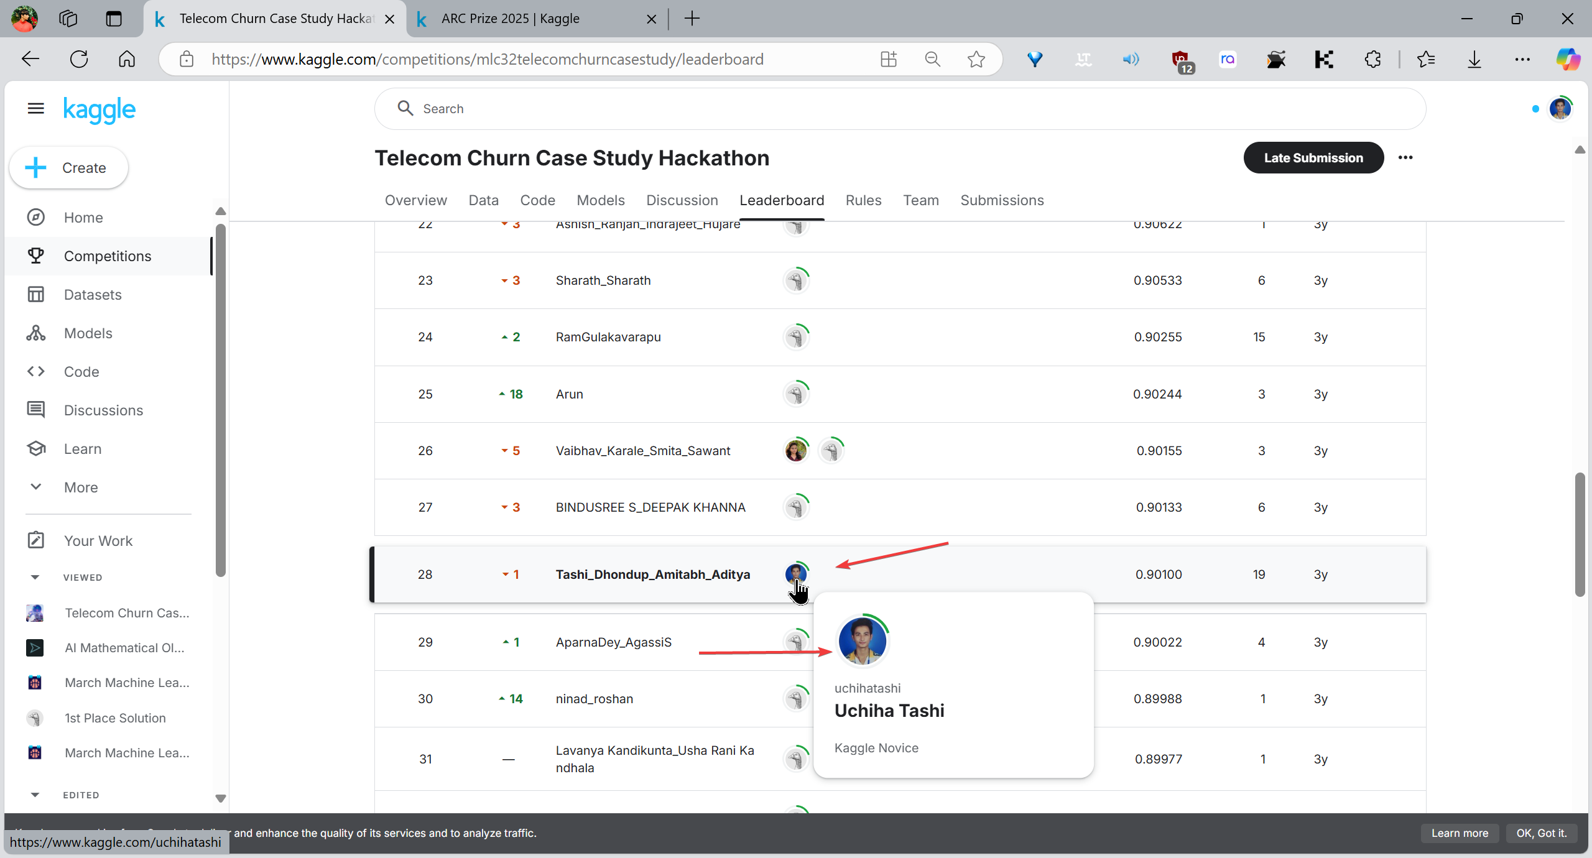

### Dataset Presentation:

Kaggle presents datasets in an organized and user-friendly manner, making it easy for participants to explore and understand the data. EvalAI lacks a similar feature for dataset presentation, which can make it more challenging for participants to access and comprehend the datasets associated with challenges.\

### Submission Details Visibility:

When submitting results on EvalAI, **participants can fill in details like Method, Method Description, Project URL, and Publication URL**. However, only the **model name and team name** are displayed publicly; the other details are visible only to the challenge host. This contrasts with Kaggle, where such information is often publicly accessible, promoting transparency and knowledge sharing among participants.

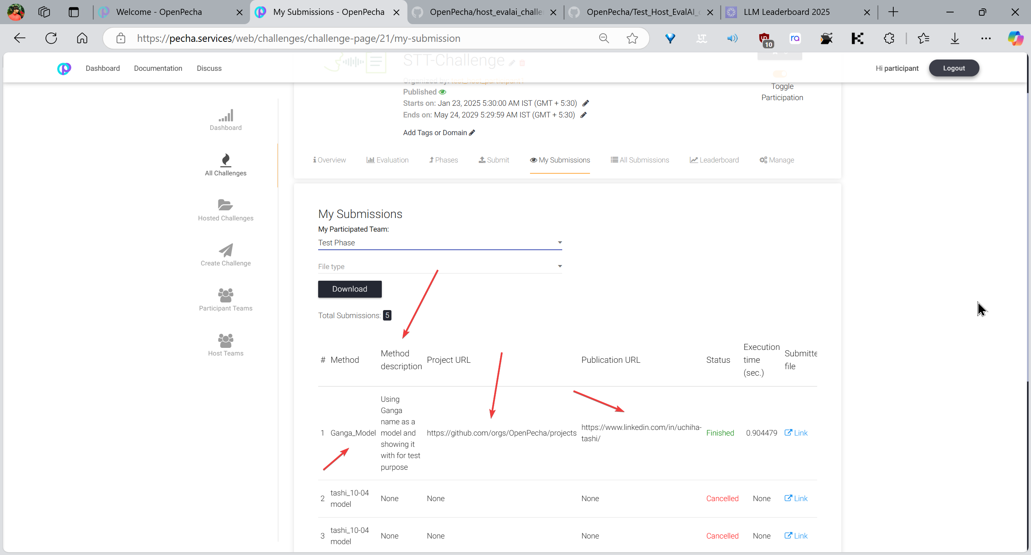

Here in the 2nd image, we can see only the participant team name and model is shown and no URL or hyper link is shared to the public. Buts it’s only visible to the host.